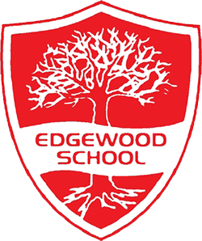
Science, D & T, Religious Education and Spanish
Year 3/4 Half Term Curriculum Overview Spring 1

We will be learning about the following objectives in our maths lessons:
- Solve problems, including missing number problems.

- Find the effect of multiplying and dividing a one or two-digit number by 10 or 100.

- Complete word problems with multiplication and division.

- Recognise, find and write fractions of a discrete set of objects: unit fractions and non-unit fractions with small denominators.

Mathematics
We would like to say a huge thank you for your continued support. On the second and third page, you will be able to access information about the Year 4 Multiplication Tables Check, when each class will swim and our reading rewards.

The children will read a text and watch a short film called The Dream Giver, which can be accessed online https://www.literacyshed.com/dreamgiver.html
They will focus on sentence structures and eventually write their own story, using Rainbow Grammar.

Then, the children will work in a group to create shadow puppets and perform
their own narrative poem to Year 1/2.

During our weekly guided reading lessons, they will read a short passage to improve their comprehension skills.
English
During our science lessons, the children will learn about forces and magnets and compare how things move on different surfaces, observe how magnets attract or repel each other and attract certain materials. Then, they will identify the part played by evaporation and condensation in the water cycle and associate the rate of evaporation with temperature.

In our DT lessons we will be looking at making our own purse or pencil case that will be stitched together, with a working fastener and embroidered designs.

The children will name, recognise and remember up to ten fruits in Spanish. Also, they will ask somebody if they like or dislike a particular fruit.

In our religious education lessons, we will look at inspirational people from Christianity, Islam and Judaism.

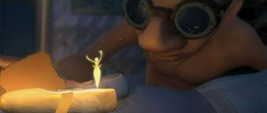

Physical Education

Children should come to school in their P.E. kit on the following days:
Verde and Amarillo Class- every Monday.
Rosa Class -every Tuesday.
They should wear black bottoms and a red top. Please can children avoid wearing football tops.
PSHE (RSE)
In our PSHE lessons, our focus value is Pride. The children will explore and discuss how our feelings and actions are important to us and why we should be proud of ourselves, our achievements and of those around us.

Weekly Homework (due every Thursday)
Geography
Computing
Homework will be assigned every Friday.
- Maths Shed: Every week, children will complete a times table test in the classroom. On Maths Shed, they will be assigned the times table they are focusing on for their weekly test. They should complete 5 games. https://www.mathshed.com/en-gb/
- Spellings: Children will complete a weekly spelling test. The spellings will be assigned every Friday and they should complete 5 games. https://www.spellingshed.com/en-gb/
- Reading: Every child has a reading diary. Please can these be signed and returned to the class teacher. Each child should aim to read at least 4 times a week to qualify for the reading reward.
In our geography lessons, children will describe and understand key aspects of physical and human geography by comparing the United Kingdom and Iceland.

For our E-safety lessons, we will discuss online bullying. Then, we will focus on coding and will be introduced to a micro: bit.
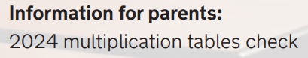
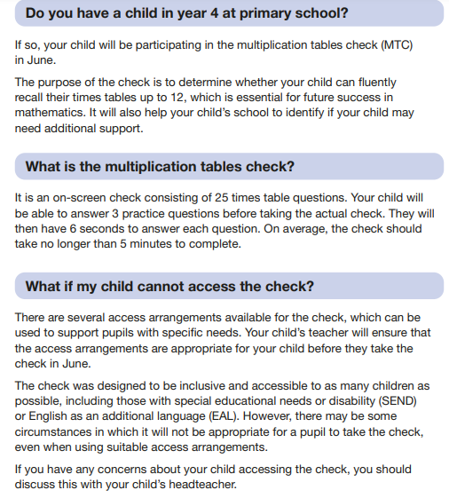
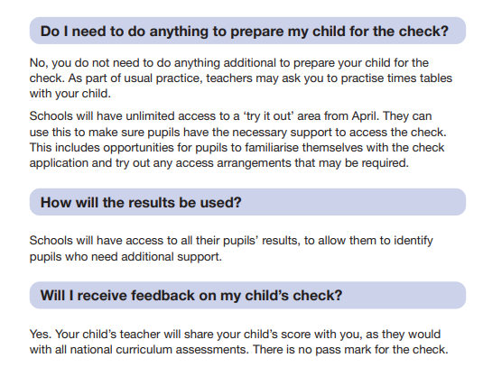

By clicking the link below you may access this information.

https://assets.publishing.service.gov.uk/media/6543c1ef9e05fd0014be7c64/2024_Information_for_parents_Multiplication_tables_check_PDFA_v1.1.pdf

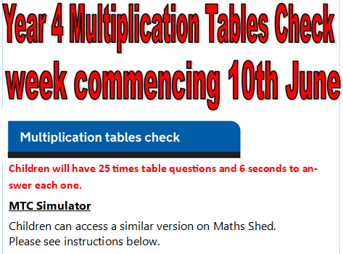
Swimming Lessons at Hucknall Leisure Centre
- Verde will swim every Thursday from 29/02/2024- 18/04/2024​

- Rosa will swim every Thursday from 25/04/2024 – 6/06/2024 ​

- Amarillo will swim every Thursday from 13/06/2024-18/07/2024

Any support is greatly appreciated.

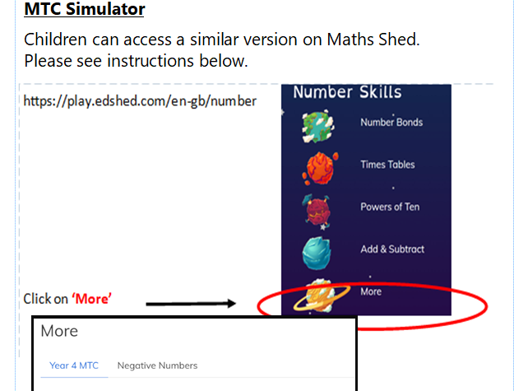

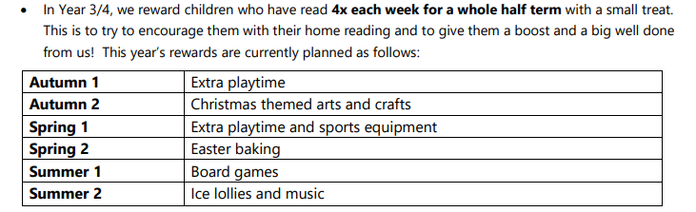
Reading Rewards

